39. Develop a system using UML for Gardener Booking System. The central system should manage the list of gardeners and their availability and appointments for the given date. The customer can book the gardener’s appointment based on availability. When the booking is confirmed, it should be updated for the gardener and beautician.

**COMPONENT:**

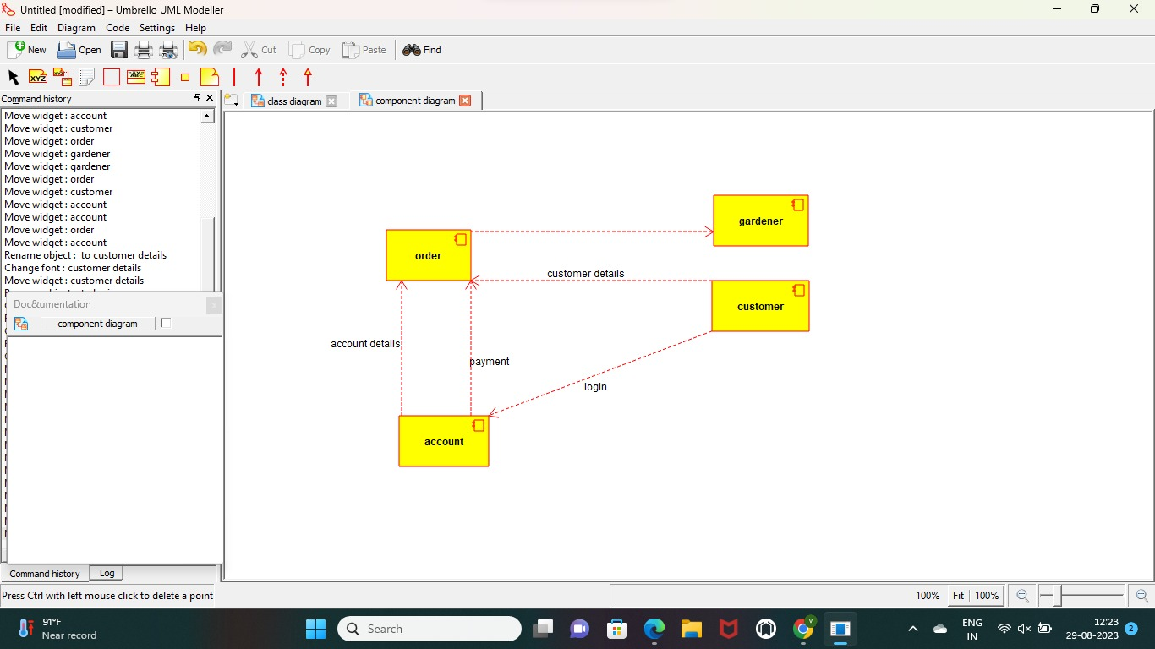

**USE CASE:**

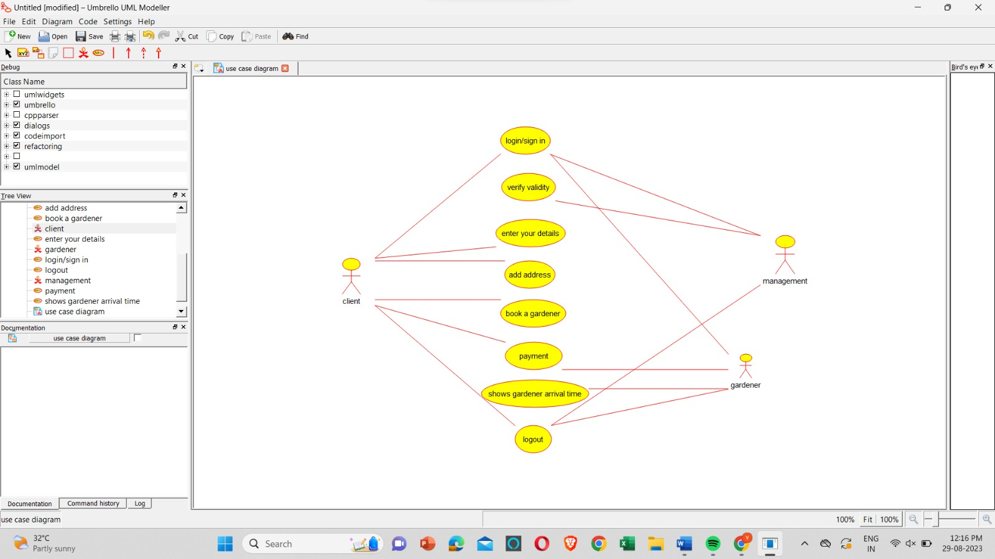

ACTIVITY:

